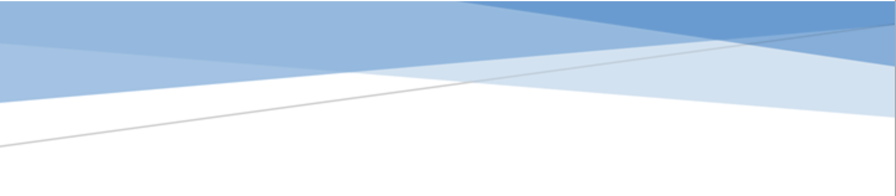



adges UI components library

**Component ID #1 – ex-banner - v1.1.0**

## Document Control

## Version History

|  |  |  |  |
| --- | --- | --- | --- |
| Version | Date | Author | Reason for Change |
| 1.0.0 | 10/24/2019 | Rana Abbassy |  |
| 1.1.0 | 10/24/2019 | Rijin Mukundan |  |
|  |  |  |  |
|  |  |  |  |
|  |  |  |  |
|  |  |  |  |
|  |  |  |  |
|  |  |  |  |

## Review History

|  |  |  |
| --- | --- | --- |
| Version | Reviewer | Date |
|  |  |  |
|  |  |  |
|  |  |  |
|  |  |  |
|  |  |  |
|  |  |  |
|  |  |  |

Table of Contents

Document Control 1

Version History 1

Review History 1

1. Document and components Purpose. 3

2. General Information. 3

3. How to use. 3

4. Component features and configure. 4

5. How to configure component. 4

6. Examples 4

# 

# Document and components Purpose.

The purpose of the document is to guide how use and configure **ex-banner** component.

# General Information.

Component Name: banner.

Extension Theme: ex-banner.

Owner: Rana Abbassy.

Version no: v1.0.0

Design

# How to use.

1. The available commands for this project .
   1. Compile : npm run gulp compile -- –path ex-accordion –extension
   2. Compile & include under ADGE tenant : npm run gulp compile -- –path ex-accordion –extension –full –dest [ADGEFolder]
   3. Deploy : npm run gulp deploy -- –path ex-accordion –extension
2. *Now project have full copy from this extension theme under the project theme and you can apply the project brand guideline and configure component based on project needs.*

# Component features and configure.

You have access now to configure component with the below item.

$banner-sub-title-color: $grey-700 !default;

$banner-sub-title-fontsize: 16px !default;

$banner-sub-title-lineheight: 19px !default;

$banner-sub-title-weight: 500 !default;

$banner-title-color: $grey-900 !default;

$banner-title-fontsize: 36px !default;

$banner-title-lineheight: 48px !default;

$banner-title-weight: 900 !default;

$banner-description-color: $grey-900 !default;

$banner-description-fontsize: 16px !default;

$banner-description-lineheight: 1.5 !default;

$banner-description-weight: normal !default;

$banner-background-img-size: cover !default;

$banner-background-img-position: center !default;

$banner-background-img-height: 100% !default;

$banner-dark-gold-color: $primary-color !default;

$banner-border-padding-value : 15px !default;

$banner-border-width : 1px !default;

# How to configure component.

There are various ways to configure the component:

1. **CSS Class Configuration (on the variant)**

These styles can be applied in the variant to get the desired result

|  |  |
| --- | --- |
| Feature | Modifier |
| switching the positions of the image from left to right or right to left. | ex-banner--switch |
| Adding border the image wrapper | ex-banner--border |

1. **Adding Built-In or Bootstrap Class (on the variant)**
   1. Spaces, Font weights, Display, Position properties etc can be added by bootstrap classes
      1. i. Spacing: <https://getbootstrap.com/docs/4.0/utilities/spacing/>
      2. ii. Flex: <https://getbootstrap.com/docs/4.4/utilities/flex/>
      3. iii. Font: <https://getbootstrap.com/docs/4.0/content/typography/>
   2. These classes should only be added to match the design
   3. For built-in classes check 7 Below to see the entire list
2. **SCSS Variable Override (on the _override.scss file)**

To configure the component we can take the above variables from section **4. Component features and configure** and add them to: adge-ph2/themes/<ADGE>/vars/_override.scss, this file with your desired changes to match the design.

1. **Complete style override**
   1. This should be the last and final option if the above 3 didn’t get you the desired output
   2. This is overwriting the SCSS of the component by adding your own style to it
   3. **Note: Take permission before doing this override**
   4. Instructions:
      1. Open the file /adge-ph2/themes/<ADGE>/sass/overrides.scss and add your own SCSS styles to override the faulty component.

# Dependencies

components-banner.css

# Examples

Examples1:

I need to change text color.

I’ll copy the below variables from extension theme.

$highlight-main-tittle-color: $primary-color;

Then will paste the above variable in project folder theme in file _custom.scss and change with any variable based on site needs.

$highlight-main-tittle-color: $secondary-color;

Examples2:

I need to the button shape from square to had a rounded corner.  
I’ll copy the below variables from extension theme.

$button-shape-square: $border-radius-value;

$border-radius-value: 0px;

Then will paste the a above variable in project folder theme in file _custom.scss and change with any variable based on site needs.

$button-shape-square: $border-radius-value;

$border-radius-value: 20px;

# 8. List of Built-In classes

**For Fonts:**

caption

big-slogan

font-italic

text-nowrap

text-white

small-text

**For Buttons:**

button--large

button--medium

button--small

button--secondary

button--tertiary

**For Dark Mode:**

high-contrast--forced

high-contrast—reset

**General:**

stretched-link

section—white

rounded

rounded-top

rounded-right

rounded-bottom

rounded-left

rounded-circle

rounded-5